Q1. Write a java program to print table of given number using method(Taking something returning nothing)

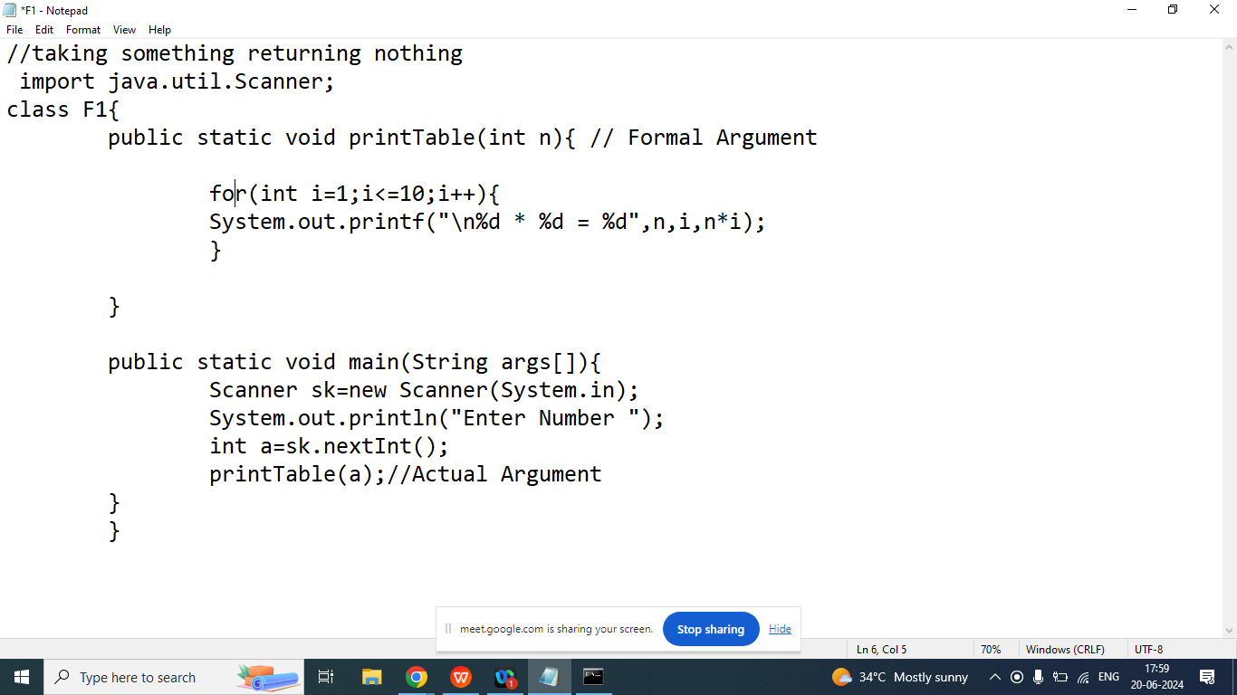

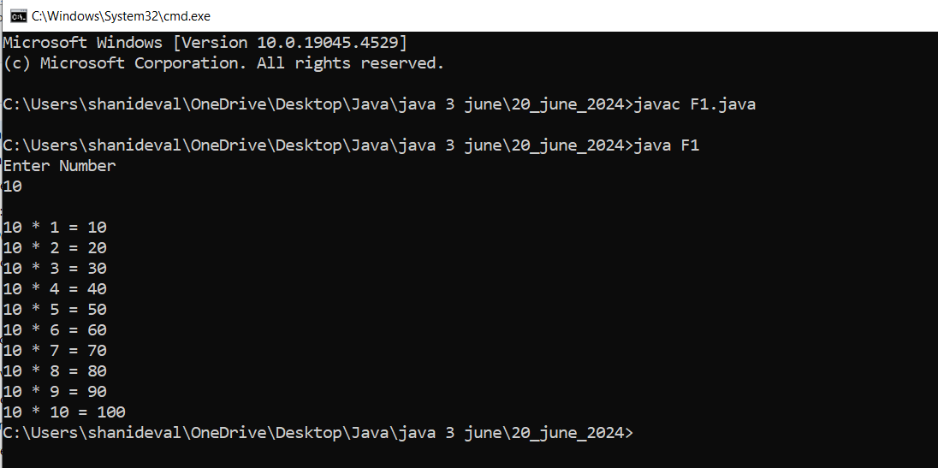

1. Taking Nothing Returning Something

Note:

1. In java method can return one value at a time

Example:

public int add(){

1. Write Input Logic
2. Perform operation
3. Return the result

}

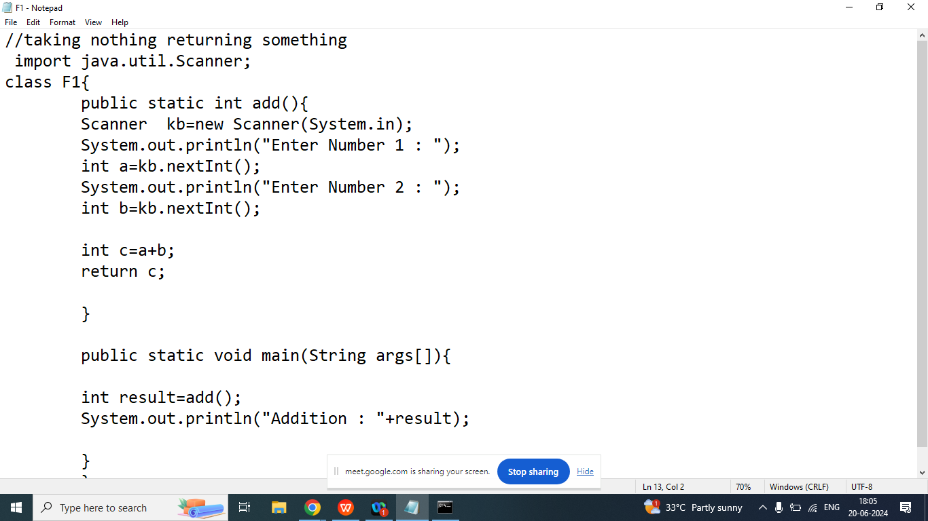

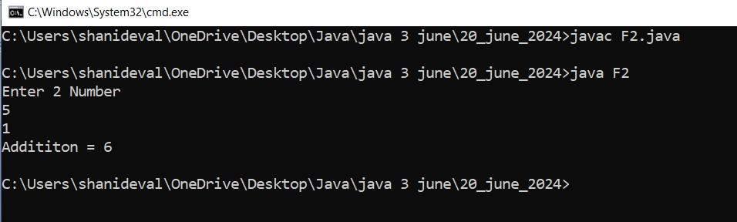

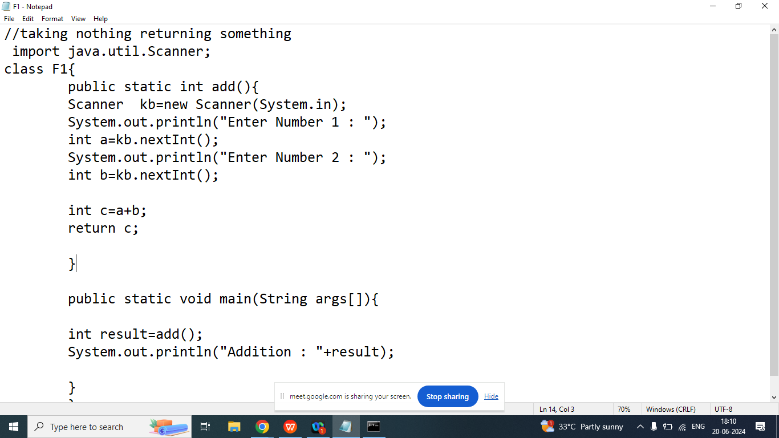

1. Taking Something and Returning Something

Example:

public int add(int,int){

//perform operation

//return result

}

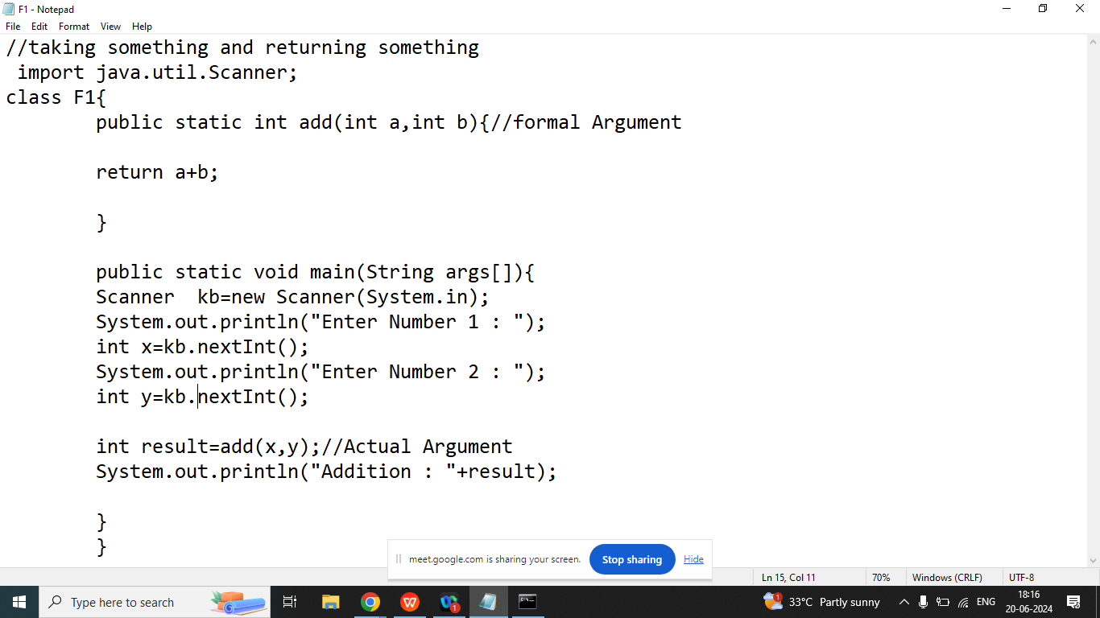

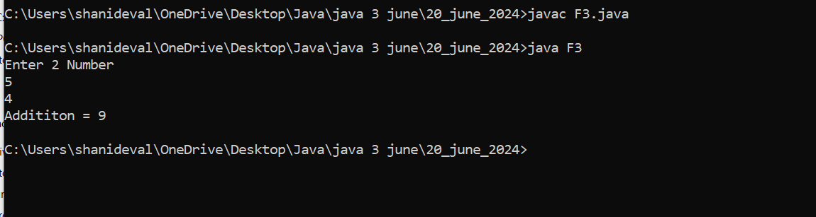

Q1. Explain Recursion in java programming?

Ans: A method called itself is known as recursion

Example : Without Recursion

